**Module 3: CloudWatch Alarms**

**Assignment**

1. Create a CloudWatch billing alarm which goes off when the estimated

charges go above $500.

Soln :

First Select the N.Virginia Region , as alarm for billing is only available in this region.



Now Go in to cloudwatch console 🡪 Alarms 🡪Billings

Now click on create Alarm 🡪

A popup will open 🡪

Here will select all these details , it shows the maximum estimation value in 6 hours.

In condition type we have select threshold type static and value 500 $ . now click on next.

Now we have to set the action for our condition.

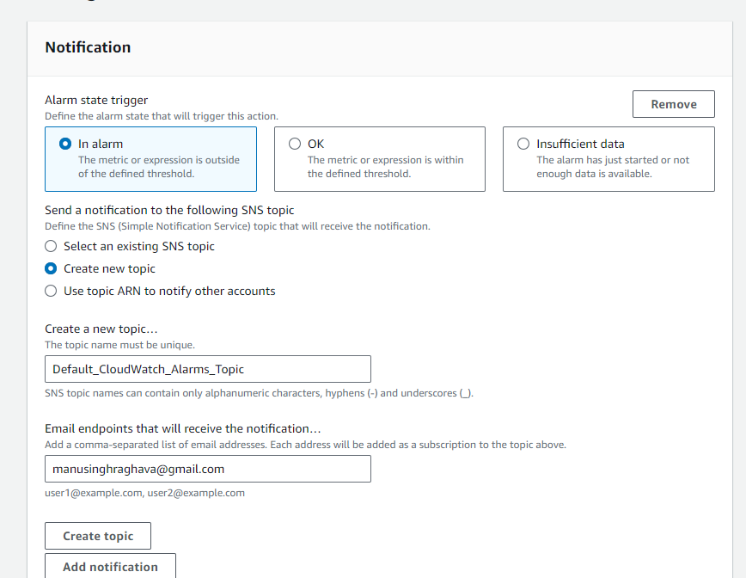

Here if our alarm got triggered it will sen notification to [manusinghraghava@gmail.com](mailto:manusinghraghava@gmail.com).

Now click next and give your alarm a Name, review it and create Alarm.

See we have created a alarm with name manubillingalarm.

Que--2Create a CloudWatch alarm which goes off to an Alarm state when the

CPU utilization of an EC2 instance goes above 65%. Also add an SNS

topic so that it notifies the person when the threshold is crossed.

Go in cloudwatch console 🡪alarms 🡪all alarms 🡪create alarm

New popup will open

* 1. First step is to select the metrics for which we have to trigger alarm.

Select Ec2 namespace here as we are creating for our instance.

Search instance id of our instance there and select cpu utilization there.

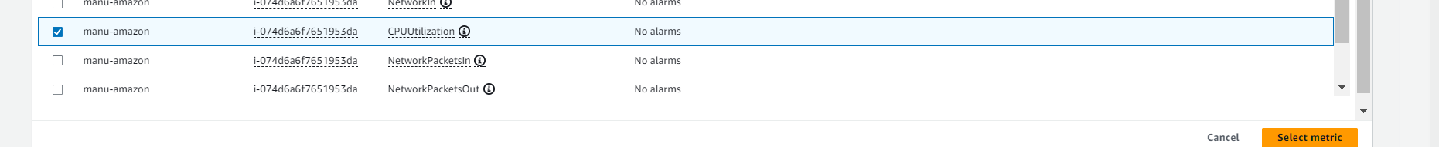

Now new pop up will open.

It is just understandable we are taking average time of 5 minutes on the metrics cpu for ec2 namespace which have the following instance id.

We can select different time and statistic like max sum etc.

Now second is the condition

What should be the threshold to activate the alarm.

Here we have selected the 60 percent threshold for our cpu utilization.

We have some additional configurations also.

How many times graph should cross the boundary is known as datapoints.

Now we have already defined the condition , so we have to take action on it also.

Lets define action

An alarm has three states:

a) insufficient data : it is when it is created. Or service is not working.

b)OK : when everything is working fine.

c)In alarm : when threshold is breached.

So here we have select to send an email to a user when threshold breached.

No define action :

We can also do other activities like scaling, lambda etc. which we will look later.

Give a alarm a name and create it.

Here we can see the state insufficient data as it is created which will turn in ok later.

Now to breach the utilization we will simulate the heavy load on our instance manually.

We can do it by using sha1sum command.

sha1sum /dev/zero & // run it 100 times on instance.

Now wait for 1 min till cloudwatch pull metrics from instance.

Now if u go on your alarm

